

**Name: Toheed Ahmed Qureshi**

**Reg NO: FA21-BSE-156**

**Section :5B**

# **LAB TASK**

# Case Study: Library Management System

## Overview

The Library Management System (LMS) is designed to facilitate the management of library resources, allowing users to borrow, return, and manage books efficiently. This report focuses on the "Borrow Book" module, outlining a fully dressed use case and providing a system sequence diagram to illustrate the interactions within the system.

# **Fully Dressed Use Case for Borrow Book:**

### Use Case ID

UC-01

### Use Case Name

Borrow Book

### Actors

* **User**: A registered library member who wants to borrow a book.
* **Librarian**: The library staff responsible for managing the borrowing process.
* **Library System**: The software system managing the library's operations.

### Preconditions

1. The user must be a registered member of the library.
2. The book to be borrowed must be available in the library's inventory.
3. The user must not have any overdue books or outstanding fines.

### Postconditions

1. The book status is updated to "borrowed."
2. The user’s borrowing record is updated to include the new book.
3. The due date for returning the book is generated and communicated to the user.

### Main Flow

1. **User requests to borrow a book**:

* The user searches for the book by title, ID.

1. **System displays book details**:

* The system shows availability, location, and borrowing rules.

1. **User selects to borrow the book**:

* The user clicks on "Borrow."

1. **System checks user eligibility**:

* The system verifies if the user is eligible to borrow (no overdue books, valid membership).

1. **System checks book availability**:

* The system confirms the book is available.

1. **Librarian processes the borrowing**:

* The librarian scans the user's membership card and the book's barcode.

1. **System updates the book status**:

* The system changes the book status to "borrowed" and sets the due date.

1. **System updates user record**:

* The system adds the book to the user’s borrowing history.

1. **System notifies the user**:

* The system sends a confirmation message to the user with details of the borrowed book and due date.

### Alternative Flows

* **A1: Book Not Available**:

If the book is not available, the system informs the user and suggests similar books.

* **A2: User Not Eligible**:

If the user has overdue books, the system notifies them of their ineligibility to borrow

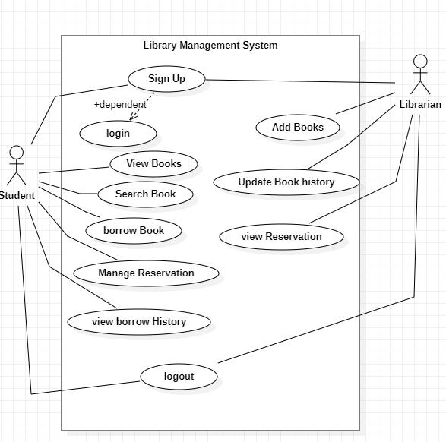

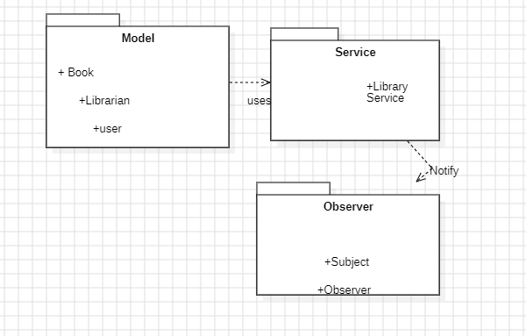

**Class Diagram** 

